Individual Report on AAA Framework (HSBC Holdings Plc)

**Module Name**: Contemporary Issues in International Business Management

**Programme**: MMN130618

**Word Count:** 1534

**Turnitin Score:**

**Declaration**

I understand the ethics of research. The work is my original work and is not submitted anywhere else.

**Student name, ID and signature.**

|  |  |  |
| --- | --- | --- |
| Student Name | ID | Signature |
|  |  |  |

**Table of Contents**

1.0 COMPANY BACKGROUND 2

2.0 ADAPTATION 3

3.0 AGGREGATION 4

4.0 ARBITRAGE 5

5.0 BALANCING STRATEGIES 6

REFERENCE LIST 8

# 1.0 COMPANY BACKGROUND

According to the Financial Times (2025), HSBC Holding Plc is among the largest international banking and financial services firms in the world, which began its operations way back in 1865 with its headquarters in London and has since been listed in both London and Hong Kong. With a global presence of over 60 countries, the company provides a wide range of services such as Retail Banking, Wealth Management, Commercial Banking, and Global Banking and Markets to its customers that serve more than 40 million (HSBC, 2024). Under the guidance of its mission of opening a world of opportunity to its customers, HSBC aims to link businesses and individuals to global financial opportunities by means of innovation and sustainability (HSBC, 2025). Ghemawat (2018) posited that its model of value creation focuses on financial inclusion, trade facilitation, and responsible banking, which is in line with the emerging international regulatory standards. As such, the ability of HSBC to operate globally with an adaptive business structure makes it a perfect study of the Adaptation, Aggregation, and Arbitrage (AAA) strategic framework in the current international business environment.

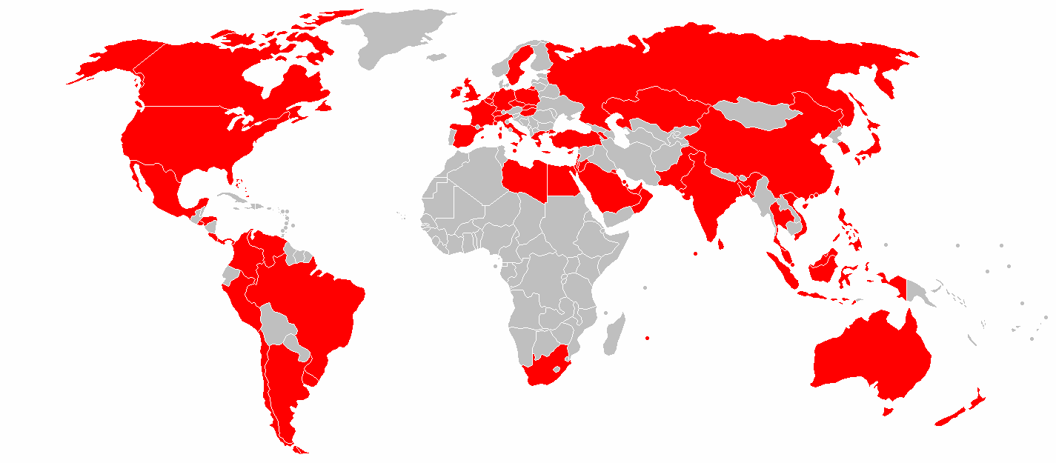

**Figure 1**: HSBC Global Presence Map showing operational countries in red (HSBC Holdings Plc, 2024a).

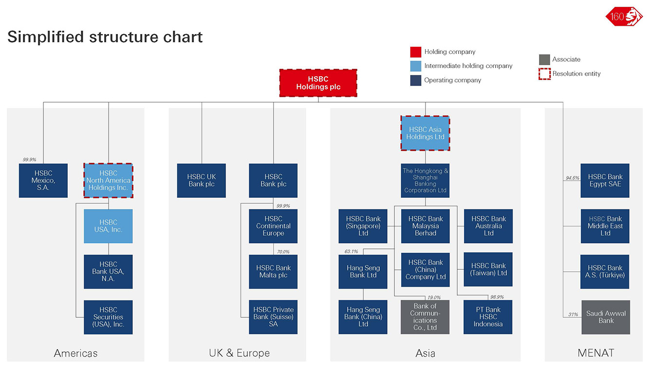

**Figure 2**: Simplified structure chart showing HSBC Holdings Plc’s global organisational divisions (HSBC Holdings Plc, 2024b).

# 2.0 ADAPTATION

The process of adapting the strategies, products, and operations of multinational companies to suit the conditions of the local market and customer preferences can be referred to as adaptation in the framework of AAA developed by Ghemawat (2018). Hill (2022) highlighted that adaptation is essential in the framework of international banking since the differences in regulations, cultures, and technologies have a significant impact on the way financial services are provided. In the case of institutions such as HSBC Holdings Plc, which has operations in over 60 countries, the local responsiveness allows it to better respond to the particular financial requirements and still adhere to the requirements of financial policies in the countries. A suitable adaptation enables HSBC to reach sustainable competitiveness through establishing customer trust, facilitating inclusion, and aligning its goals with the national economic goals (HSBC Holdings Plc, 2025).

There is a great product and service adaptation in HSBC in its global network. An example is the provision of Islamic banking by the bank in Middle Eastern markets, as these are in accordance with the Sharia principles to appeal to and maintain culturally oriented clients (ElMassah and Abou-El-Sood, 2021). HSBC has grown SME lending initiatives in the Asia-Pacific region to facilitate entrepreneurship and digitalisation of finances (HSBC, 2024). In Europe, HSBC Holdings Plc (2025) reported that it incorporates Environmental, Social, and Governance (ESG) programs into its product range, which is concerned with green finance and sustainability-linked loans. The bank further considers that it adapts to regulations, ensuring compliance with local regulators such as the UK Financial Conduct Authority (FCA), the Monetary Authority of Singapore (MAS), and the Hong Kong Monetary Authority (HKMA) (HSBC, 2024). Moreover, HSBC uses culturally targeted marketing through campaigns such as “Together We Thrive,” supported by digital banking tools in regions.

The adaptation has greatly improved HSBC's market performance, compliance, and customer loyalty. Statista (2020) reported that the agility to embrace new technologies that meet regional expectations is evident in its mobile-first approach in Asian markets. The reliability of its operational resilience and strengthening of its brand through its constant adaptations to legal, social, and environmental models have enhanced its brand credibility (de Souza and de Souza, 2023). Consequently, HSBC has maintained strong positions in emerging economies such as China, India, and the UAE, where responsiveness to local customers is a significant factor in retaining customers (HSBC, 2024). Hence, adaptation has enabled HSBC to strike the right balance between global effectiveness and local relevance, which further strengthens its competitive advantage in the changing global financial environment.

# 3.0 AGGREGATION

Aggregation in AAA aims to achieve global efficiency and operational synergy across markets (Ghemawat, 2018). In the case of a multinational financial institution such as HSBC Holdings Plc, the concept of aggregation is vital to ensuring cost efficiency in managing its global customer base. HSBC can enjoy economies of scale and uniformity in service delivery through the consolidation of operations and decision-making at the regional level (Das, 2016). To this end, this strategy enables the bank to operate smoothly across 60 countries, balancing global control and local execution through standardised processes and centralised systems.

The aggregation strategy is evident in HSBC's shared IT and data infrastructure, which promotes cybersecurity globally and enables unified digital banking (HSBC, 2025). The organisation is efficient, risk-managing and customer-oriented. The shared services model of the bank enables the regulation, risk measurement, and financial reporting to be handled on a shared basis, eliminating the duplication of effort (Financial Times, 2025). Moreover, Trudeau and McLarney (2017) confirmed that HSBC promotes international branding, in which the company maintains the same identity and communication standards across markets while moving knowledge to other regions. As an example, new digital practices in the Asian markets have been introduced in Europe and will facilitate the alignment of operations and diffusion of knowledge (Statista, 2025).

Aggregation helps HSBC achieve economies of scale, better governance, and stronger international brand presence. The strategy will boost cost-effectiveness, operational resilience, and risk management by optimising strategic control (HSBC, 2024). Nevertheless, Tahri (2023) warns that over-standardisation can reduce flexibility in responding to local market demands. In the case of HSBC, aggregation enhances efficiency globally; it must be complemented by adaptation to maintain local relevance and customer confidence. In sum, the aggregation strategy used at HSBC can be viewed as an example of how a global bank can incorporate processes while remaining flexible across various financial settings.

# 4.0 ARBITRAGE

According to Ghemawat (2018), arbitrage describes how a firm can use differences in markets, i.e., differences in costs, resources, regulations, or availability of capital, to achieve a competitive advantage. Arbitrage can be used in the international banking industry to exploit financial imbalances and regulatory differences across the world (Daniels and Radebaugh, 2016). In the case of HSBC Holdings Plc, the strategy is important in maximising profitability by differentiating the interest rates, tax structure, and labour costs in its international network. With the ability to locate its operations and financial activities in strategic hubs, HSBC is able to manage the resources efficiently and minimise the costs of transactions (Wilson and Choudhury, 2025).

HSBC has various types of arbitrage to maximise value creation. According to HSBC Holdings Plc (2025), it applies financial arbitrage due to a proactive involvement in capital and foreign exchange markets and will enable the bank to take advantage of interest rate disparities and currency fluctuations. The concept of talent arbitrage is based on outsourcing and offshoring IT and customer support services to a new place with lower costs, like India, the Philippines, and Malaysia, enhancing operational efficiency (PwC, 2023). Moreover, regulatory arbitrage is used to enable HSBC to use comparatively loose regulatory environments in financial centres such as Hong Kong, Singapore, and Dubai, where offshore banking and investment models are more beneficial (Reuters, 2024). This means that all strategies precondition a competitive advantage and profitability of HSBC, even in the volatile global markets.

Notwithstanding such strengths, the arbitrage strategy adopted by HSBC is not risk-free. The growing international attention to cross-border taxation and stricter regulatory requirements are some of the challenges that make it difficult to maintain such strategies (Wilson and Choudhury, 2025). Labour offshoring and tax optimisation also pose certain ethical issues that can impact the HSBC corporate image (EY Reports, 2024). Ghemawat (2018) identifies that the key to successful multinational corporations is balancing between arbitrage, adaptation, and aggregation to ensure that the value of a corporation remains legitimate and viable in the long term. Consequently, HSBC should ensure compliance, transparency, and responsible governance and capitalise on market differences to remain profitable and stakeholder-confident in its various business operations across the globe.

# 5.0 BALANCING STRATEGIES

The HSBC Holdings Plc is tactical in implementing the three elements of the AAA framework by Ghemawat (2018); nevertheless, its operations reflect a strong focus on Aggregation and Adaptation. Aggregation facilitates the requirement of the bank to be globally consistent and cost effective, whereas Adaptation guarantees responsiveness to the local requirements of the cultures and regulations (Nahar, 2021). This twin focus allows HSBC to have a centralized control of technology and compliance and provide local lending products like Islamic financing and product lending based on ESG. A combination of both the strategies has enabled HSBC to maintain global governance but at the same time remaining relevant in the various markets (HSBC Holdings Plc, 2025).

Further on, Aggregation and Adaptation should remain the key priority of HSBC to strike a balance between global integration and market flexibility. Arbitrage as a source of substantial returns can create regulatory and ethical risks due to the growing demands of financial transparency (EY Reports, 2024). Balancing the global efficiency and local responsiveness will continue to give HSBC an upper-hand, especially as the digital transformation is bringing about a change in the banking industry. This ratio is in line with the mission of the company to open up a world of opportunity by means of sustainable and customer-oriented financial services (HSBC, 2025).

# REFERENCE LIST

Daniels, J.D. and Radebaugh, L.H. (2016) *International business environments and operations*. Pearson Education Limited. Available at: https://repositori.mypolycc.edu.my/handle/123456789/5415 (Accessed: 25 October 2025).

Das, S. (2016) ‘An Overview of the Activities and the Financial Performance of the Hong Kong and Shanghai Banking Corporation Limited (HSBC)’, *Ewubd.edu*, 13(2). Available at: http://dspace.ewubd.edu/handle/2525/1004.

de Souza, M.C.S. and de Souza, R.S. (2023) ‘Law enforcement, social demands and reputation risks as drivers of compliance functions: a comparative analysis of the largest banks’ disclosures in the UK and Brazil’, *Crime Law and Social Change*, 81, pp. 255–280. Available at: https://doi.org/10.1007/s10611-023-10116-8.

ElMassah, S. and Abou-El-Sood, H. (2021) ‘Selection of Islamic banking in a multicultural context: the role of gender and religion’, *Journal of Islamic Marketing*, ahead-of-print(ahead-of-print). Available at: https://doi.org/10.1108/jima-05-2020-0160.

EY Reports (2024) *EY GCC Banking Sector Outlook 2024 report*, *Ey.com*. Ernst & Young Global Limited. Available at: https://www.ey.com/en_ps/technical/banking-capital-markets/gcc-banking-sector-outlook/ey-gcc-banking-sector-outlook-2024-report (Accessed: 25 October 2025).

Financial Times (2025) *HSBC’s Asia Pivot and Global Integration Strategy*, *Ft.com*. London: Financial Times. Available at: https://www.ft.com/hsbc (Accessed: 25 October 2025).

Ghemawat, P. (2018) *Redefining Global Strategy : Crossing Borders in a World Where Differences Still matter.* Boston, Mass.: Harvard Business School Press.

Hill, C. (2022) ‘International Business: Competing in the Global Market Place’, *Strategic Direction*, 24(9). Available at: https://doi.org/10.1108/sd.2008.05624iae.001.

HSBC (2024) *HSBC Holdings Plc Annual Report and Accounts 2024 Contents*. London : HSBC Group. Available at: https://www.hsbc.com/-/files/hsbc/investors/hsbc-results/2024/annual/pdfs/hsbc-holdings-plc/250219-annual-report-and-accounts-2024.pdf (Accessed: 25 October 2025).

HSBC (2025) *Who we are | HSBC Holdings plc*, *HSBC*. Available at: https://www.hsbc.com/who-we-are (Accessed: 25 October 2025).

HSBC Holdings Plc (2024a) *Global presence map [Online image]* [London: HSBC Group]. Available at: https://www.hsbc.com/who-we-are/our-global-presence (Accessed: 25 October 2025).

HSBC Holdings Plc (2024b) *Simplified structure chart* [Online image], *London: HSBC Group*. Available at: https://www.hsbc.com/who-we-are/our-structure (Accessed: 25 October 2025).

HSBC Holdings Plc (2025) *Sustainability - HSBC UK*, *www.hsbc.co.uk*. Available at: https://www.hsbc.co.uk/sustainability/ (Accessed: 25 October 2025).

Nahar, S. (2021) *Analysis On the Marketing Strategy and Competitive Advantage of Banking Industry in Bangladesh: An Entrepreneurial Case Study of HSBC Bank*, *Academy of Entrepreneurship Journal*. Allied Business Academies. Available at: https://www.academia.edu/download/91954584/Analysis-on-the-marketing-strategy-and-competitive-advantage-of-banking-industry-1528-2686-27-4-552.pdf (Accessed: 25 October 2025).

PwC (2023) *Banking transformation through global delivery centers*. London: PricewaterhouseCoopers. Available at: https://www.pwc.lu/en/banking/docs/pwc-banking-luxembourg-trends-figures-2023.pdf (Accessed: 25 October 2025).

Reuters (2025) ‘HSBC Swiss unit culls wealthy Middle Eastern clients amid regulator scrutiny, FT says’, *Reuters*, 24 August. Available at: https://www.reuters.com/business/finance/hsbc-swiss-unit-culls-wealthy-middle-eastern-clients-amid-regulator-scrutiny-ft-2025-08-24/ (Accessed: 25 October 2025).

Statista (2020) *Online banking penetration in Asia 2020, by country*, *Statista*. Available at: https://www.statista.com/forecasts/1150290/online-banking-penetration-in-asia-by-country?srsltid=AfmBOopwia0Co6yWV4vpFk1_NWuxHOKxiyj65FcPDtaFeydcXGAHtreL (Accessed: 25 October 2025).

Tahri, A. (2023) ‘Consumer based brand equity in retail banking industry: a cross analysis of a domestic and global bank operating in the UK (HSBC vs Barclays)’.

Trudeau, C. and McLarney, C. (2017) ‘How can banks enhance international connectivity with business customers?: A study of HSBC.’, *IUP Journal of Business Strategy*, 14, pp. 20–39. Available at: https://research.ebsco.com/linkprocessor/plink?id=88550356-8ee9-39b5-bdb7-e97d53751846.

Wilson, H. and Choudhury, A. (2025) *HSBC Quarterly Profit Stung by Higher Costs, China Charge*, *Bloomberg.com*. Bloomberg. Available at: https://www.bloomberg.com/news/articles/2025-07-30/hsbc-profit-squeezed-by-costs-higher-impairment-charges (Accessed: 25 October 2025).